# Project 1: Batch File Processing

# Overview

This project will aim to build a batch file processor. The scope of this effort is to build a tool that parses and executes a XML batch file containing a number of commands. Each command executed by our batch processor will be executed as a process and communicate (pass information) using files or pipes.

# Commands

The following sections describe the four commands to be implemented by this batch processor.

## wd Command

|  |  |
| --- | --- |
| **wd** | |
| **Description** | Sets the batch’s working directory i.e. the directory the batch will execute within. |
| **Arguments** | |
| id | A name that uniquely identifies the command in the batch file. |
| path | The path to the working directory |

### file Command

|  |  |
| --- | --- |
| **File** | |
| **Description** | Identifies a file that is contained within the batch’s working directory. |
| **Arguments** | |
| id | A name that uniquely identifies the command in the batch file. |
| path | The path to the file including its name and extension. The path will always be evaluated relative to the working directory specified by the ‘wd’ command. |
|  |  |

### cmd Command

|  |  |
| --- | --- |
| **cmd** | |
| **Description** | A command that will be executed in a process. |
| **Arguments** | |
| id | A name that uniquely identifies the command in the batch file. |
| path | The path to the executable. If the path is relative, it will use the system’s executable PATH to locate the executable file. |
| args | This is a string that contains the arguments that will be passed to the executable specified by the ‘path’ option. |
| in | This is the ID of the file (specified in a file command) that will be directed to the executable process’s stdin stream. |
| out | This is the ID of the file (specified in a file command) that will be directed to the executable process’s stdout stream. |

### pipe Command

Pipe implements connection between two processes (P1 | P2) where the output from P1 is directed (piped) to the input of P2. So this command requires two subcommands that will be executed concurrently.

|  |  |
| --- | --- |
| **pipe** | |
| **Description** | Pipe is an interconnection between two processes (cmd). The two cmd’s identified |
| **Arguments** | |
| id | A name that uniquely identifies the pipe in the batch file. |
| Cmd Element | Two CMD elements that define the P1 and P2 described above. Both commands will be executed concurrently with P1 stdout copied to P2 stdin. |

# Batch Files to Be Executed

Each of the following sections describes a batch file that your processor will execute. You have been provided the input data files numberdata.txt and randomwords.txt.

### Batch1: batch1.xml

A batch that executes the DOS DIR command and directs output into a file named dirout.txt.

<batch>

<wd id=*'swd1'* path=*"work"* />

<file id=*"file1"* path=*"dirout.txt"* />

<cmd id=*"cmd1"* path=*"cmd"* args=*'/c dir'* out=*'file1'* />

</batch>

### Batch2: batch2.xml

A batch that executes two commands. Each command sorts the contents of randomwords.txt . The first command sorts and writes its output to sortedwords.txt. The second command reverse sorts and writes its output to reversesort.txt.

<batch>

<wd id=*'swd1'* path=*"work"* />

<file id=*"file1"* path=*"randomwords.txt"* />

<file id=*"file2"* path=*"sortedwords.txt"* />

<cmd id=*"cmd1"* path=*"sort"* in=*'file1'* out=*'file2'* />

<file id=*"file3"* path=*"reversesort.txt"* />

<cmd id=*"cmd2"* path=*"sort"* args=*'/R'* in=*'file2'* out=*'file3'* />

### </batch>

### Batch3: batch3.xml

A batch that implements an operation in two steps interconnected through files.

The first command reads the file numberdata.txt which containing several lines and each line contains several numbers. This command will output a several lines where each output line contains the sum of the numbers read from the input file.

The second command will average the numbers read from each line of the file produced by the first command. This command will output the average as a single number.

This batch ties the two operations together using files i.e. the output of cmd1 is the input of cmd2.

Notice that these two commands are implemented as Java applications that have been packaged into jar files. The java runtime executes a jar file using the ‘-jar’ option i.e. java –jar addLines.jar.

<batch>

<wd id=*'swd1'* path=*"work"* />

<file id=*"file1"* path=*"numberdata.txt"* />

<file id=*"file2"* path=*"sumout.txt"* />

<cmd id=*"cmd1"* path=*"java.exe"* args=*"-jar addLines.jar"* in=*'file1'* out=*'file2'* />

<file id=*"file3"* path=*"avgout.txt"* />

<cmd id=*"cmd2"* path=*"java.exe"* args=*"-jar avgFile.jar"* in=*'file2'* out=*'file3'* />

</batch>

### Batch4: batch4.xml

A batch that implements an operation in two steps interconnected through files.

This batch is similar in function to batch3 except that the two commands will be interconnected though a pipe.

The <pipe> command joins two commands. The output (stdout) from the first command is directed into the input (stdin) of the second command**. NOTE: For the same of simplicity, you can assume that your pipe element contains two and only two <cmd> elements.**

<batch>

<wd id=*'swd1'* path=*"work"* />

<file id=*"file1"* path=*"numberdata.txt"* />

<file id=*"file2"* path=*"avgout1.txt"* />

<pipe>

<cmd id=*"addLines"* path=*"java.exe"* args=*"-jar addLines.jar"* in=*'file1'* />

<cmd id=*"avgFile"* path=*"java.exe"* args=*"-jar avgFile.jar"* out=*'file2'* />

</pipe>

</batch>

### Batch5: batch5.broken.xml

This is an example of a batch containing an error. The file ID in cmd1 is incorrect (i.e. filee2).

<batch>

<wd id=*'swd1'* path=*"work"* />

<file id=*"file1"* path=*"numberdata.txt"* />

<file id=*"file2"* path=*"sumout.txt"* />

<cmd id=*"cmd1"* path=*"java.exe"* args=*"-jar addLines.jar"* in=*'file1'* out=*'filee2'* />

<file id=*"file3"* path=*"avgout.txt"* />

<cmd id=*"cmd2"* path=*"java.exe"* args=*"-jar avgFile.jar"* in=*'file2'* out=*'file3'* />

</batch>

When executed this file should produce an error message. The format of the error message is up to the team, but for example:

Error Processing Batch Unable to locate OUT FileCommand with id: filee2

utdallas.cs4348.batchProcessor.ProcessException: Unable to locate OUT FileCommand with id: filee2

at utdallas.cs4348.batchProcessor.commands.CmdCommand.execute(CmdCommand.java:49)

at utdallas.cs4348.batchProcessor.BatchProcessor.executeBatch(BatchProcessor.java:16)

at utdallas.cs4348.batchProcessor.BatchProcessor.main(BatchProcessor.java:39)

Notice that the error message is produced by an exception handler. This should be a design feature of your processor i.e. convert any library (IOException) or error conditions detected by application logic into an application-specific exception class. Catch and display those exceptions in the main().

# Project Design

This section discusses a basic design that should be applied to your implementation. The design makes use of polymorphism in the parsing and executing of the four command types present in the batch language.

## Application Structure

The following UML class diagram presents an overview of the project’s design. The application is divided into three processing classes:

BatchProcessor: This is the main class which drives both the parsing of the batch file into commands and the execution of those commands.

Batch: This class maintains the N Commands that were parsed from the given batch file.

BatchParser: This class builds an instance of Batch containing the N Commands parsed from the XML document provided in the batch file. The parser is responsible for visiting each of the XML elements in the given XML document and generating the correct Command subclass from the element

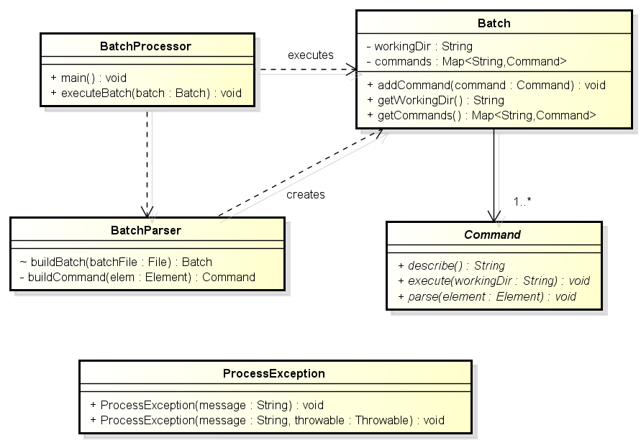

## Commands Classes

The following UML class diagram describes the recommended structure of the classes that implement each of the four types of batch commands that our batch processor can execute. Note the use of polymorphism in the three basic operations that can be performed on a Command. Note that Command is an abstract class that defines three abstract methods: **describe**() used to print a message to the console when the Command is executed. **parse**() should parse and extract the information contained in the given XML Element. **execute**() should execute the command.

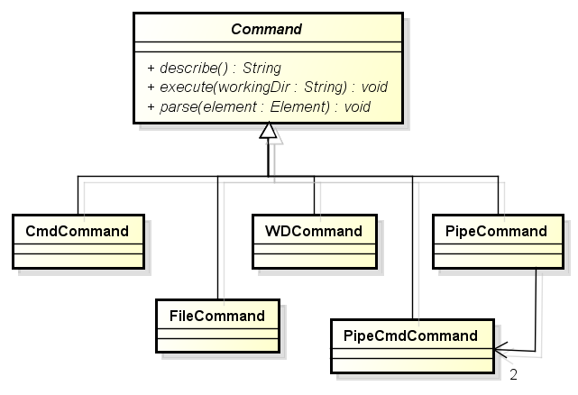

## Example Execution

The following UML sequence diagram provides an overview of the two stages of the batch processor’s execution. 1) The processor parses the Commands from the given XML batch file. 2) The processor executes each of the Commands.

